Acts 4:5-22 - Salvation in Jesus’ Name
Purpose: Lean on Jesus rather than any other
- God is For Us
- Come Praise and Glorify
- Kids: God’s Great Family
- My hope is built
- Let the Nations be Glad

God is For Us by CityAlight

[Intro]
|D / / /|G / / /|
|D / / /|G / / /|

[Verse 1]
D G D
We won't fear the battle, we won't fear the night
G D Bm A
We will walk the valley with You by our side
D G D
You will go before us, You will lead the way
G D Bm A
We have found a refuge, only You can save

[Chorus]
D G D
Sing with joy now: our God is for us
G D Bm A
The Father's love is a strong and mighty fortress
D G D
Raise your voice now, no love is greater
G D A
Who can stand against us if our God is for us

[Intro]
|D / / /|G / / /|

[Verse 2]
D G D
Even when I stumble, even when I fall
G D Bm A
Even when I turn back, still Your love is sure
D G D
You will not abandon, You will not forsake
G D Bm A
You will cheer me onward with never-ending grace

CHORUS

[Intro]
|D / / /|G / / /|
|D / / /|G / / /|

[Bridge]
G A
Neither height nor depth can separate us
Bm D/F#
Hell and death will not defeat us
G A
He who gave His son to free us
Bm A
Holds me in His love
G A
Neither height nor depth can separate us
Bm D/F#
Hell and death will not defeat us
G A
He who gave His son to free us
Bm A
Holds me in His love

CHORUS X2

[Outro]
|D / / /|G / / /|
|D / / /|G / / /|

[End]
D

Intro:
F# F# D G G G
F# F# D G G G
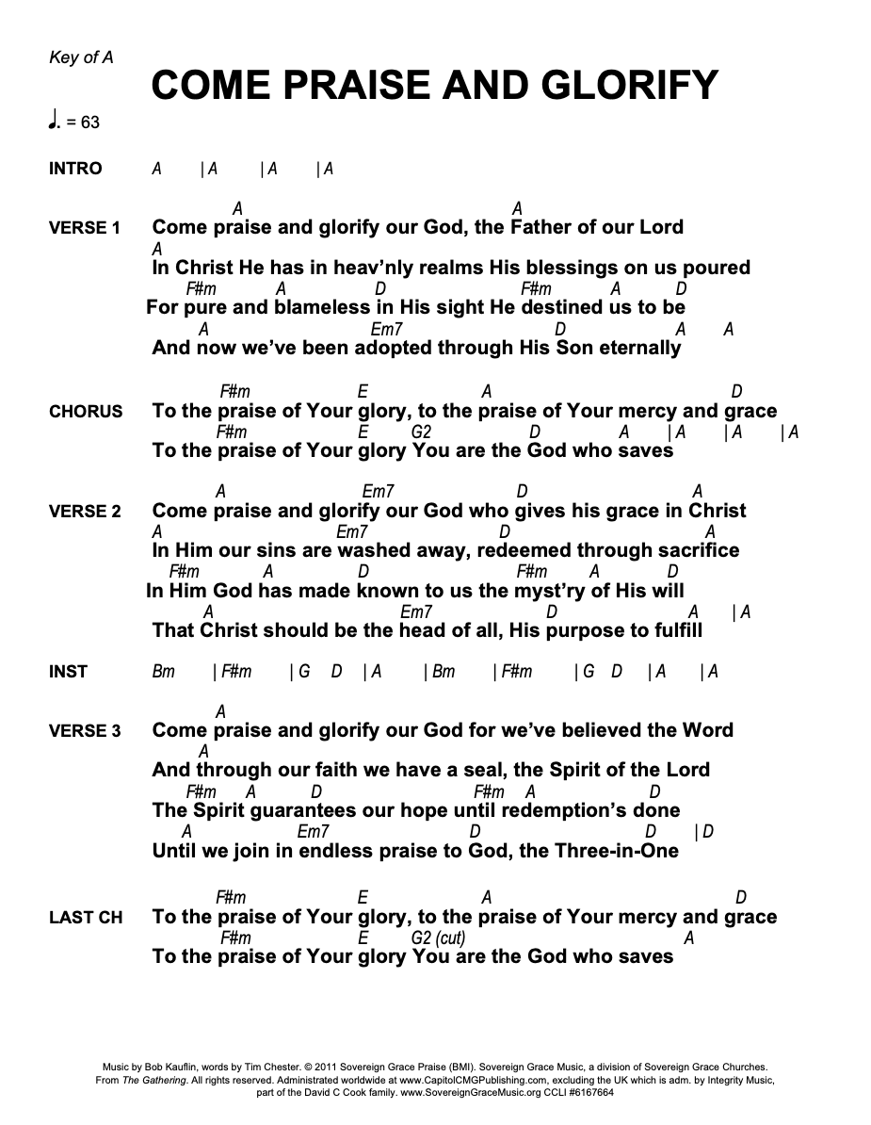
HOOK: (D F# A B D BA x2
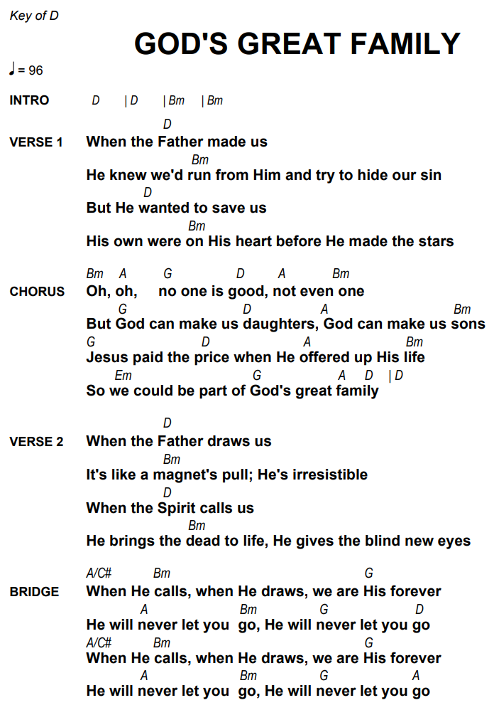
BAB GF# EF# BABGF# EF#) x2

My Hope is Built

Verse 1:
Intro:
G A F#/D G x2

G A
My hope is built on nothing less
Em G
Than Jesus' blood and righteousness
G A
I dare not trust the sweetest frame
Em G
But wholly lean on Jesus' name

Chorus:
D Em
On Christ the solid rock I stand
F#/D G A
All other ground is sinking sand
Bm A G A F#/D G
All other ground is sinking sand

G A F#/D G

Verse 2:
G A
When darkness seems to hide his face
Em G
I rest on his unchanging grace
G A
In every high and stormy gale
Em G
My anchor holds within the veil

CHORUS

Verse 3:
G A
His oath, his covenant, his blood
Em G
Support me in the whelming flood
G A
When all around my soul gives way
Em G
He then is all my hope and stay

CHORUS

Verse 4:
D D
When he shall come with trumpet sound
D Bm
Oh may I then in him be found
D D
Dressed in his righteousness alone
D G
Faultless to stand before the throne

CHORUS
Let The Nations Be Glad

LET THE NATIONS BE GLAD
[Intro]
C F C F

[Verse 1]
C
Let the glory of the Lord forever be our
joy
G F
May redemption be the theme of our song
C
For by grace we have been saved

And by grace we shall proclaim
C G
To the corners of the earth that Christ
F G
has come

[Chorus]
F C F G
Let the nations be glad, let the people
Am
rejoice
F C G
For salvation belongs to our God
F C
Let the whole earth be filled with the
F G Am
praises of the Lord
F C G
For salvation belongs to our God
F G C F C F
Let the nations be glad

[Verse 2]
C
Through the ages gone before

Through the trial and the sword

Many saints and martyrs conquered though
G F
they died
C
Still we're holding out the cross

Crossing oceans suffering loss
C G
Shall endure all things to win the crown
F G
of life

CHORUS

[Verse 3]
C
As your holy church goes forth, in the
Holy Spirit's power
G
With the glories of the Gospel to explain
F
Am
Now we pray Your kingdom come
G/B C
And we pray Your will be done
F G
For the honor and the glory of Your
Am
name

CHORUS x2 (first time till 2nd last line)

